**Time- 2.0 H SCIENCE-IX M.M-90**

**General Instructions:**

(i)The question paper comprises of two sections ,A and B .You are to attempt both the sections.

(ii)All questions are compulsory.

(iii)There is no overall choice.

(iv)All questions of section A and all questions of section B are to be attempted separately.

(v)Question numbers 1 to 3 in section A are one mark questions .These are to be answered in

one word or in one sentence.

(vi)Question numbers 4 to 6 in section A are two marks questions.These are to be answered in

about 30 words each.

(vii)Question numbers 7 to 18 in section are three marks questions .These are to be answered in

about 50 words each.

(viii)Question numbers 19 to 24 in section A are five marks question.These are to be answered in

about 70 words each.

(ix)Section B are multiple choice questions based on practical skills.Question numbers 25 to 33 are

one mark questions .Question numbers 34 to 36 are two marks question .You are to select one

most appropriate response out the four provided to you

**1.**A battery lights the bulb .Describe the energy charges involved in the process.

**2.**What percentage of Earth’s surface is covered by water?

**3.**Which subkingdom of plant has hidden reproductive structures?

**4.**Explain the cause of the following:

(i)While drawing water from a well, the bucket of water appears to be heavier as it comes out of the

water.

(ii)The force required by a man to move his legs immersed in water is less than the force for the same

movement in air.

**5.**On the basis of Thomson model of an atom, explain how the atom is neutral as a whole.

**6.**List four important characteristic features of chordates.

**7.**You lift a heavily packed carton of mass ‘m’ in vertically upward direction through a height ‘h’.What is

the work done (i)by you on the carton ,(ii)by force of gravity on the carton?

A body of mass 5 kg initially at rest is subjected to a force of 20 N.What is the kinetic energy acquired

by the body at the end of 10 s?

**8.**Define pressure and give its SI unit. Why does an object float or sink when placed on the surface of

water?

**9.**How much work is done by our earth in making one complete revolution around the sun?Give reason.

How much time will a pump of 1 kW power take to lift 500 kg of water to a height of 40m?Given that

=10 ms-2

**10.**(a)In which of the three media ,air ,water or steel ,does sound travel the fastest at a particular

temperature?

(b)The frequency of a sound source is 100 Hz .How many times does it vibrate in a minute?

(c)How does speed of sound in air affected by temperature?

**11.**Shweta studies in class VII in a public school and is quite intelligent .She carefully observes her

surrounding environment and has many queries in her mind. It requires more effort to go upstairs

than going down the stairs .Why does she feel fatigue after briskly walking for few kilometers .She

fells hungry after playing a game of football and so on. She could not find answer of such questions.

She asked her father ,who explained to her the concepts of work and energy Now she was satisfied

as she knew the answers of her queries .

(i)In your opinion, what is the difference in work done by a person while going upwards from work

done at the time of going downwards?

(ii)What qualities does Shweta possess?

(iii)How much work does a person do while catching a cricket ball of mass 0.15 kg coming with a

speed of 20 m s-1?

**12.**Convet into mole

(a)12 g of oxygen gas (b)20 g of water (c)22g of CO2

**13.** Compare the properties of electrons, protons and neutrons.

**14.**Why is atmosphere essential for life?

**15.**What is greenhouse effect?

**16.**Gayatri was having some swelling on the neck for sometimes .She was constantly losing weight and

felt tired all the time .Her friend Seema asked her about the problem she was facing Gayatri replied

that had been diagnosed with goiter and was undergoing treatment.

(i)Deficiency of which element causes goiter?

(ii)What precautions are being taken by the people to prevent goiter?

(iii)How is the disease treated?

**17.**(a)Name four categories of pathogens that cause diseases.

(b)Give one example of human disease caused by each pathogen

**18.** On a rainy day Shubham was playing with his elder brother in the lawn of his house.He saw a

segment limbless worm coming out from the soil .Hw got scared and screamed loudly “Snake ,snake

“.On hearing him, his brother ran to him immediately .On seeing the segmented worm his brother

realized that it was not snake but an harmless worm .He pacified his brother and explained about it.

(a)What justification do you think that Shubham ‘s brother might have given to him?

(b)Can you an example of some other organism of the same phylum that sucks blood.

(c)Why is the segmented worm called as the poor farmer‘s best friend?

**19.** (a)How does the sound produced by a vibrating body in a medium reach our ear?

(b)Flash and thunder are produced simultaneously .However, thunder is heard a few seconds after

the flash is seen. Explain why.

(c)A sound wave travels at a speed of 339 m s-1.If its wavelength is 1.5 cm, what is the frequency of

the wave?will it be audible?

**20.** (a)Show that for a freely falling object the sum of its potential energy and kinetic energy remains

unchanged at all points during its fall.

(b)Certain force acting on a 20 kg mass changes its velocity from 5 m s-1 to 2m s-1.Calculate the work

done by the force.

**21.**(a)Give the chemical formula of the following compounds:

(i)Hydrogen nitride (ii)Hydrogen peroxide (iii)Hydrogen carbide.

**22.**Arrange the following in the increasing order of mass in grams

(i)One gram of silver (ii) Two gram atoms of N

(iii)One mole of calcium (iv) Two grams of sodium

**23.**In tabulated from differentiates between dicots and monocots and also cite examples for the same.

**24.**(a)Define nomenclature .Give the scientific name for peacock.

(b)Who introduced the binomial system of nomenclature? Enlist the rules or conventions followed

while writing the scientific names.

**SECTION-B**

**25.**In the experiment of verifying the law of reflection of sound the clock as well as ear should be placed

just at the edge of tubes so that:

(a)only sound passing through tube NO.1 and reflected from wall comes through tube No.2 received.

(b)Tubes may transmit sound.

(c) disturbance due to wind is avoided.

(d) sound produced by clock becomes a musical sound.

**26.**A body exerts a force F on a surface of surface area A.Presasure P acting on the surface is:

(a) (b)  (c)  (d) 

**27.**In the experiment of finding speed of a pulse propagated through a slinky, the pulse is produced

(a)by pulling the slinky towards us.

(b)by pushing the slinky so as to compress it

(c)by giving a jerk to slinky in vertically upward direction only.

(d)by giving a jerk to slinky in a direction perpendicular to its length.

**28.**The observed weights of a solid body, when immersed in tap water and strong saltish water, are W1

and W2 respectively .Then

(a)W1<W2 (b) W1>W2 (c) W1=W2 (d) W1=2W2

**29.**Law of conservation of mass states:

(a)A chemical compounds is always made up of the same elements combined in a fixed ratio.

(b)Matter can neither be created nor destroyed.

(c)At constant temperature, volume of a given mass of a gas changes inversely as the pressure.

(d)At constant pressure, volume of a given mass of a gas varies directly as te temperature on Kelvin

scale.

**30.**Which of the following is not a dicot plant?

(a)Mustard (b) Pea (c) China rose (d)Onion

**31.**The correct sequence of the lifecycle of mosquito is:

(a)Eggs ,pupa,larva,adult (b)Adult,larva,pupa,adult

(c)Eggs,larva,pupa,adult (d)Larva,pupa,eggs,adult

**32**.A student wants to observe a spiracle of a cockroach .She should observe the region on its body

shown by the label.

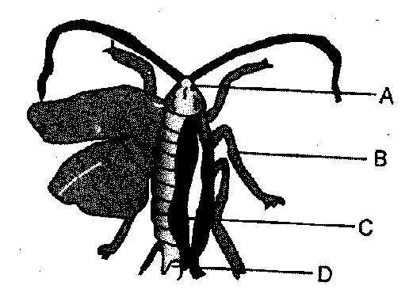

(a)A (b)B (C)C (d) D

**33**.In the figure of the earthworm given below the horizontal lines, throughout the body represent:

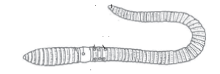

(a)Cells of the body (b)Cell walls separating the cells of the body.

(c)Horizontally arranged muscles of the body (d)Septa separating segments of the body.

**34.**Below are the pictures of four different organisms .What ids their correct sequence of identification

of their group to which they belong?

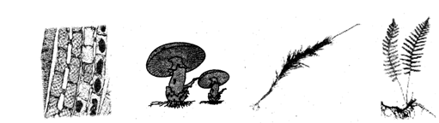

(a)Bryophyta,Fungi,Thallophyta,Pteridophyta (b)Thallophyta,Bryophyta,Fungi,Pteridophyta

(c)Thallophyta,Fungi,Bryophyta ,Pteriodophyta (d)Thallophyta,Fungi,Pteridophyta ,Bryophyta

**35.**The least count nof the measuring cylinder used and the volume of the solid taken in the ‘set

up’Shown here are respectively:

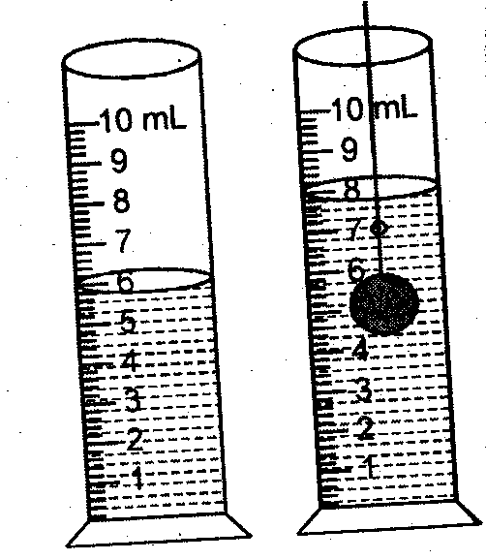

(a)0.1 mL and2.0 Ml (b)0.1mL and2.0Ml (c)0.2mL and 2.2mL (d)0.2mL and 2.4 mL

**36.**A laboratory had the following apparatus available in it:

(A)Two thin hollow tubes (B)An intense and broad source of sound.  
 (C)An internse,pointed detector of sound. (D)A sharp pointed detector of sound.

(E)A well polished deterctor of sound. (F)A whilte painted thrmocol sheet.

A student can do his experiment on verification of laws of reflection of sound successfully by

choosing the apparatus labeled as

(a)A,C,D,E (b)A,C,E (c)A,B,D,E (d)A,C and D